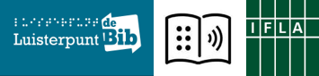

(IFLA) Guidelines 2.0 for public libraries and persons with print disabilities, also for Rafiq, Nancy and Alice?
-- IFLA LPD Symposium February 28, 2018 – Muntpunt, Brussels --
For many years, the different IFLA-sections have been developing guidelines on a wide variety of topics, such as ‘To measure is to know’, ‘the online catalogue’, ‘Web 2.0 and library services for young adults’, and more.
Also the libraries for the blind and later the libraries serving persons with print disabilities (LPD) published interesting guidelines over the years:
- How to organise Conferences, Satellite Meetings and Training Seminars (2011)
- Guidelines created by the World Blind Union (WBU) on how to make the use of PowerPoint and other visual presentations accessible (2007)
- Designing and Building Integrated Digital Library Systems - Guidelines (2005)
- Libraries for the Blind in the Information Age - Guidelines for development (2005)
- Guidelines for Library Service to Braille Users (1998)
The latest substantive guidelines published by IFLA / LPD date from 2005 and deal with digital content, the importance of good interfaces and digital library services for the specific target group of blind and partially sighted persons. The rise of the internet, the digital framework and new technologies – including Daisy – allowed for many possibilities in terms of accessibility.
In the meantime, however, more than 10 years have passed and we have witnessed many new developments. Daisy and ePub technology evolves. We download and stream our books. eBooks, eReaders and audio books are trending in many countries. Scientific research on sight and hearing problems, dyslexia, mobility and accessibility keeps developing and questioning itself.
In many countries, the target group of people with a print disability has been expanded. We reached out to print disabilities such as dyslexia, to (also temporary) physical disabilities such as MS, to mental disabilities, to aphasia, etc.
This list is not exhaustive, and depending on the goodwill of publishers and authors, there is a wide range of opportunities.
A big group of newcomers that come to the fore are migrants wanting to learn the language of their new home country. Can we welcome them within the arrangements for reading material for persons with print disabilities? Don’t they have a reading disability in the language they don’t know but want to learn and read? We all realise that Daisy audio books can be a great benefit for people who learn a new language: they can read and at the same time listen to the Daisy book. On top of that, the book can be read to them at the speed they want. Who doubts the effectiveness?
Children of newcomers also learn the new language. Many good practices of read-aloud-projects, often with beautiful (adapted) reading material, custom-made, have been developed for them in many countries.
There is also the Marrakesh Treaty (MT), which is highly important for people with print disabilities all over the world. The MT offers many chances, also for people that are now excluded, because no adapted services exist in their countries, because the existing adapted services do not recognize their disabilities as print disabilities, because their eagerness to learn and curiosity towards (books in) different languages can be hampered, …
So much material and possible subjects for an interesting symposium. We have chosen to open other doors and to link – for us – new target groups to the usefulness (or not) of guidelines 2.0 for public libraries. Yes, for public libraries, because in unity, there is strength!
Programme
9.30 coffee and welcome by Geert Ruebens, director of Luisterpuntbibliotheek
10.00 presentation by chair of the day Saskia Boets, operational manager of Luisterpuntbibliotheek
We know Maddy (78) whose eyesight is deteriorating and Bart (42) who is blind. We are also getting to know better and better what Lucas (10) with dyslexia wants and needs. But what can we do for Rafiq (30) and his son Issam (6), who have recently arrived in our country and are eager to learn Dutch fast (and well). How can we help Nancy (60), who suffers from dementia, and Alice (16) who is deaf?
Saskia outlines a few reader profiles and draws attention to the necessity (or not) of guidelines for public libraries, tailored to these reading profiles.
10.15 Alice (16) is deaf
Legimus, the Swedish online catalogue for persons with print disabilities also contains sign language books/DVDs. The Apple Shelves (areas with easy-to-read materials for children) in Swedish public libraries all display book DVDs in sign language. Who came up with this initiative? Tips and tricks from the Swedish practical experience …
Also in Flanders, the attention for books and eBooks in sign language increases. What role can public libraries play?
- Presentation by Kristina Passad (Librarian and the Head of Unit for Acquisition, Swedish Agency for Accessible Media - MTM, Sweden)
Together with UNICEF and WIPO, The DAISY Consortium developed a project on books in sign language. Rather than developing separate books using proprietary technologies, they looked to see how this could be built together with established standards (EPUB) to create a universal book. Deaf and hard of hearing people were involved in the project.
- Presentation by Richard Orme (Chief Executive Officer, DAISY Consortium, UK)
- Questions from the audience
11.00 Nancy (60) suffers from dementia
Zorgbib, a service of Belgian Red Cross-Flanders, sets up library points in (among others) hospitals and residential care centres. As the demand for materials increased for people that can’t be reached with ‘normal’ books, Zorgbib started to look for adapted materials for people with dementia. In a few years, they have turned into a specialist in the matter at hand: reminiscence books and DVDs, specialized puzzles, games and creative materials are now a flourishing part of their collection. A wide range of beautiful materials that often remain out of sight for public libraries.
[Bibliotheekblad, a specialist journal for libraries in the Netherlands and Flanders, published a heart-warming report on public library services for people with dementia. (No. 5, 2017)]
- Presentation by Liesbeth Vercammen, staff member at Zorgbib, where she started a specialized collection for the elderly and people with dementia (Zorgbib Belgian Red Cross-Flanders, Belgium)
- Questions from the audience
11.35 Rafiq (30) and his son Issam (6) are new in the country
Many libraries in many countries play an important role in newcomers’ lives. Usually, it starts with a guided visit to the library in the context of an integration and/or language course. The library is mostly a warm place, where newcomers can go for all kinds of help and counselling, for language courses and conversation tables, or just the daily newspaper with a coffee.
Daisy books can be great tools to learn the language of the new country: read and listen at the same time, with the correct pronunciation and different reading speeds. In Flanders and Brussels, for example, a number of books in simple language are available in Daisy for people learning Dutch. This is possible thanks to the collaboration with the authors and the publishers. This selection of books is, however, very limited, while so many Daisy books are available.
- Presentation by Stijn Callewaert, Netwerk Brusselse bibliotheken (Brussels Public Library Network). The Brussels public libraries find it important to make newcomers feel welcome, and this is reflected in their services. They also have a long tradition of reading to children from families with a different home language (e.g. ‘Boekenbende aan Huis’). Let’s look at what could be …
- Questions from the audience
- Question for the audience: (how) should or can this service for newcomers develop?
12.15 Lucas (10) has dyslexia, Maddy (78) has a deteriorating eyesight, Bart (42) is blind …
The target groups of people with print disabilities are diverse and multi-faceted. Does (not) every target group demand a particular approach with adapted materials and a specific provision of services?
Saskia Boets draws conclusions from the presentations and reflects on the necessity of specific guidelines for library services.
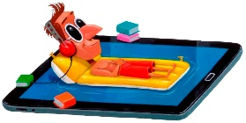 | 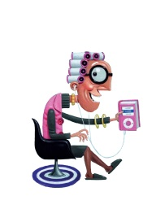 | 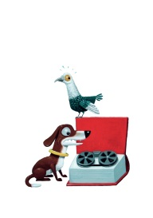 | 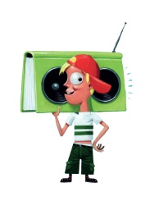 | 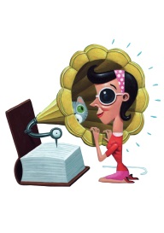
12.30 Lunch
13.30 Library services for persons with print disabilities: do we welcome Alice, Nancy, Rafiq and Issam, … ?
- A personal reflection by Richard Orme (Chief Executive Officer, DAISY Consortium, UK)
- Questions and thoughts from the audience
14.00 Accessibility Guidelines for Public Libraries in Finland
In Finland guidelines for the accessibility of public libraries were developed: ‘Libraries for an inclusive society’, based on the ‘design for all’ idea.
- Presentation by Kirsi Ylänne, Chair LPD, Accessibility Specialist Celia, Finland
14.15 The new European Accessibility Act
What does the new European Accessibility Act (2017) mean for library services to persons with print disabilities? We focus on the accessibility of eBooks.
- Presentation by Alejandro Moledo, New Technologies and Innovation officer, the European Disability Forum (EDF)
14.30 The Marrakesh Treaty Guide for Public Libraries
The Marrakesh Treaty (June 2013 - formal name: ‘Marrakesh Treaty to Facilitate Access to Published Works for Persons Who Are Blind, Visually Impaired, or Otherwise Print Disabled’) is of great importance for the target group of people with visual or other print disabilities; not only to broaden the target group but also to allow import and export of accessible versions of books. Spurred on by IFLA, guidelines for libraries are being developed.
- Presentation by Anthea Taylor, Manager Accessible Information Library Services,
Vision Australia
14.45 News from LPD and closing word by Chair Kirsi Ylänne
15.00 Closing Session
- Presentation on 10 years of Luisterpuntbibliotheek by Geert Ruebens, director of Luisterpunt
15.15 Reception
16.30 FIN

